File Management:

Create, rename, or delete multiple files based on a pattern or criteria.

Organize files into a specific directory structure.

Back up or archive important files.

Text Processing:

Search and replace text within a group of files.

Extract specific information from log files or data sets.

Format text files in a particular way

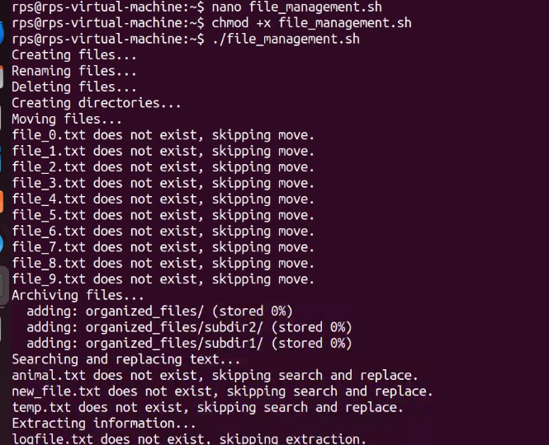

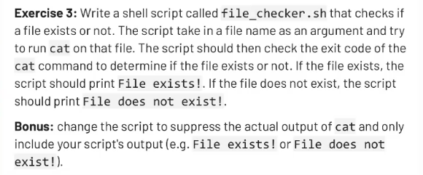

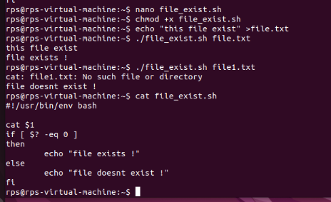

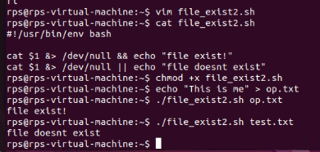

Write a shell script called

timely_greeting

.sh that greets

you based on the current time. The script should call the

date

command, extract the current hour (look into using

%H) and then print

the following greeting based on the time.

If it is between 5AM (05:00) and 12PM (12:00):

Good morning!

If it is between 12PM (12:00) and 6PM (18:00):

Good afternoon!

If it is between 6PM (18:00) and 5AM (5:00):

Good night!

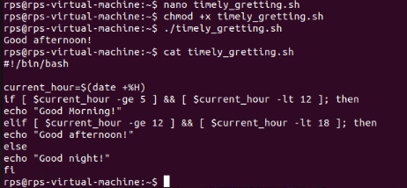

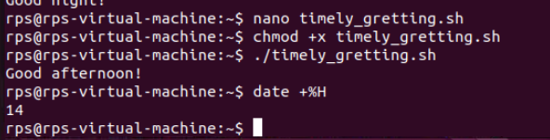

Extend the script to include multiplication and division operations, and handle division by zero appropriately.

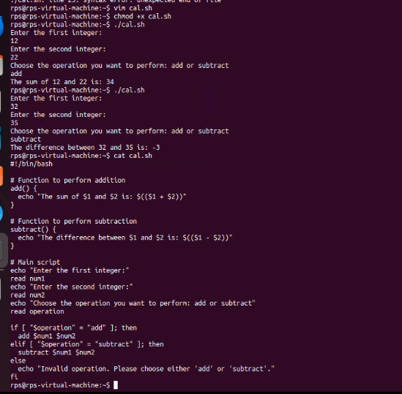

Title: Create, Write, and Read Files Using Shell Script

Objective:

Develop a shell script that can create a file, write user-provided content into the file, and then read and display the content of the file

